Executive Summary

The internship provided a comprehensive introduction to the practical aspects of [industry/field]. The program aimed to bridge the gap between academic learning and real-world application, offering a hands-on experience in a professional setting.

In existed system, users have to go that particular car and user should reserve it. Here, time consuming is more and there is no guarantee that car will come after waiting for long time. We will not able know the fair details of the distance of our journey.

**Tasks Undertaken:**

* Project Assistance.
* Research and Analysis.
* Documentation.
* Skill Development.

**Key Learnings:**

* Practical Application.
* Team Collaboration.
* Time Management.
* Industry Insights.
* Professional Etiquette.

**Table of Contents**

|  |  |  |
| --- | --- | --- |
| Sl.no |  | Page.no |
| 1 | Introduction. | 3 |
| 2 | Organization Profile. | 7 |
| 3 | Job Responsibilities. | 9 |
| 4 | Learning and Methodology. | 13 |
| 5 | Tools and Technologies. | 17 |
| 6 | Results and Impact. | 21 |
| 7 | Conclusion. | 25 |
| 8 | References | 28 |

**Chapter 1 : Introduction**

An internship is a professional learning experience that offers meaningful, practical work related to a student’s field of study or career interest. An internship gives a student the opportunity for career exploration and development, and to learn new skills. It offers the employer the opportunity to bring new ideas and energy into the workplace, develop talent and potentially build a pipeline for future full-time employees.

Following the growth of social networking applications during the last few decades, the demand for solutions to manage vast amounts of data is increasing rapidly. Data management is becoming a key element for many operations in the media industry. Companies have increasingly implemented Content Management Systems (CMS) as a tool to manage various processes of content creation and distribution. These systems can range from simple file management applications to sophisticated systems handling all types of data and integration with a wide range of platforms. This covers the process of developing one such system. The system acts as a centralized control panel and enables the user to manage company product’s data. This will help their website meet requirements from website stores, maintain users thus increase marketing and revenue.

The social media applications in itself have Billions of users. It uses fundamental concepts like user authentication, Database management, UI/ UX design, and software development while taking it to an advanced level. The aim of this project is to Generally recreate a website which provides similar functionalities to the websites like Facebook, application while trying to improve on some of the aspects from a developer’s point of view.

1.1 Background information about the work:

The project will be developed on new technologies like React.js and Material UI while using Google’s Firebase for Authentication and Database management. The process of scrolling to see who has order your pizza gets a information. There should be an alternative for the process and that is why we suggest adding a search bar in the section so that a user can easily navigate through their menu leading to a better user experience.

React JS is a declarative, efficient, and flexible JavaScript library for building reusable UI components. It is an open-source, component-based front end library responsible only for the view layer of the application.

React JS was created by Jordan Walke , who was a software engineer at Facebook. It was initially developed and maintained by Facebook and was later used in its products like WhatsApp & Instagram. Facebook developed React JS in 2011 in its newsfeed section, but it was released to the public in the month of May 2013.

A React JS application is made up of multiple components, each component responsible for outputting a small, reusable piece of HTML code. The components are the heart of all React applications. These Components can be nested with other components to allow complex applications to be built of simple building blocks. React JS uses virtual DOM based mechanism to fill data in HTML DOM. The virtual DOM works fast as it only changes individual DOM elements instead of reloading complete DOM every time.

Reasons to use React Js:

1. Simple -> With React, you express how your website should look at any given point in time and it will automatically manage your UI updates when your underlying data changes.
2. Declarative -> With changes in Data, React automatically refreshes with it and it knows to only update the changed parts and not the whole UI. This improves the overall performance.
3. Reusable -> With React we can build reusable components, we majorly build components with the help of react. As they are encapsulated components it makes the code reuse, testing, and removal of errors pretty easy.

Simple, declarative, and reusable. These are the top 3 major qualities of React.

To create React app, we write React components that correspond to various elements. We organize these components inside higher level components which define the application structure. For example, we take a form that consists of many elements like input fields, labels, or buttons. We can write each element of the form as React components, and then we combine it into a higher-level component, i.e., the form component itself. The form components would specify the structure of the form along with elements inside of it.

1.2 Objectives and goals of the internship:

* Internships are generally thought of to be reserved for college students looking to gain experience in a particular field. However, a wide array of people can benefit from Training Internships in order to receive real world experience and develop their skills.
* An objective for this position should emphasize the skills you already possess in the area and your interest in learning more.
* Internships are utilized in a number of different career fields, including architecture, engineering, healthcare, economics, advertising and many more.
* Some internship is used to allow individuals to perform scientific research while others are specifically designed to allow people to gain first-hand experience working.
* Utilizing internships is a great way to build your resume and develop skills that can be emphasized in your resume for future jobs. When you are applying for a Training Internship, make sure to highlight any special skills or talents that can make you stand apart from the rest of the applicants so that you have an improved chance of landing the position.

1.3 Scope and significance of the internship:

* An internship gives a student the opportunity for career exploration and development, and to learn new skills. It offers the employer the opportunity to bring new ideas and energy into the workplace, develop talent and potentially build a pipeline for future full-time employees.
* Internships give you a platform to establish critical networking connections.
* Internships help students learn all about workplace culture, employee relations, and leadership structure, which should help them on board in their first professional job with more ease than if they haven't had professional experience. Build your resume.
* Internships provide exposure to the real world.
* This is one of the key benefits of an internship. Job listings usually include minimum requirements, such as a necessary level of education or work experience. When you enter the workforce for the first time after completing your education or training program, you are probably not going to have much work experience. Internships are the perfect way to fill this gap. You could gain valuable insight into business processes in your chosen field, take part in professional meetings and perform tasks assigned to you in a professional setting.
* Internships allow you to learn more about yourself.
* Internships are a practical way to expand your professional network. Meeting others and making friends in your field can be beneficial to your future career, as they could potentially recommend you for open positions. The professionals you meet during your internship could be valuable connections for your future job prospects, so showing enthusiasm, curiosity and commitment can help professional contacts.
* Internships equip you with more than just technical skills
* Internships can act as preliminary employment training, and human resources personnel and managers can observe you in various situations to determine if you might be a valuable addition to the team. Even if that particular company does not have any available permanent positions, we can still move on with contacts and mentors in our field.
* Internships allow you to gain a competitive edge.
* The most valuable mentor relationships often start with a personal connection that enhances the experience for both the mentor and the mentee. Working as an intern may provide you with opportunities to meet a potential mentor naturally and establish a relationship that helps guide your career path. Working alongside them, you have the chance to reveal your personality and show deference and respect while seeking guidance and input. An internship can create a situation where your relationship develops organically, even if your future full-time position is at a different company.
* The supervisors and mentors we meet during our internship can be valuable references for us as we pursue a full-time job. If we are positive and hardworking, managers may be more inclined to recommend us for open positions. References generated from an internship can be valuable in our job searches because those managers now know us personally and have seen how we contributed to the company. They can be specific when describing our developing skills or how we are educated and prepared for employment.

**Chapter 2: Organization Profile**

I carried out my internship at Pentagon Space .Offers internship opportunities to the students in need of education about software technology. The goal of the program is to provide students with the necessary equipment to get a Bachelor of Science in Technology, as well as to provide them with a practical component of the theoretical work they have been studying at our university and to help students comprehend the operations in the IT industry. In this internship I learned how to create a web app using ReactJS to help clients/users to work in a more efficient and transparent way. I understood how a back- end and Front-End of a software works. I leaned a wide variety of coding niches, from databases. I learned about few technologies regarding web development in the training period. After that, I implemented it to build a website. I learned how to work in a team and coordinated with the team members. I learned about the basic features of project. Also worked on Vercel/Netlify and Mongodb.

**2.1 Overview of the organization:**

**[Its mission, vision and core values]**

Mr. Ravi Shankar Aradhya has started Pentagon Space in the year 2020 to address the issues of Technological drift that requires upskilling and reskilling of existing professionals in the companies. At the same time we aim at reaching out to the masses and make High end technology available to aspirants of knowledge at an affordable price. The future being data the vision, mission and goal of the company is oriented towards delivering the technologies to “master the future” which in fact is the tagline of the company.

This Founder is known for his teaching techniques which help the students in easy understandability of the most complicated concepts. With the teaching experience of 14 years and training 1000’s of students now he has decided to take up the challenge to deliver the most in demand skill set currently in the industry, which is the future. Backed by his extraordinary teaching skills are the placement opportunities that Pentagon space provides which help students to complete the cycle of gaining knowledge.

**2.2 Organizational structure:**

Pentagon Space have a robust teaching method to ensure optimum level of career success to the freshers and aspiring tech professionals. Pentagon Space is the right place for people who want to master niche technologies. They provide courses on various niche technologies such as Java Full Stack, Python Full Stack, Software Testing, Machine Learning, Artificial Intelligence, and many more. Over 50,000 students found their courses beneficial to grow their careers. They connect the right talents with the opportunities; they have 3,214 hiring partners and on average 500+ students placed in a month.

Pentagon Space would be the focal point for the people who want to master the future with niche technologies and the clients who are in search of resources can be deployed from the first day of work.

Their aim is to make technical education of niche technologies affordable and reach out to the masses to bring a change in society so that the nation is driven towards progress.

“Data is the Future, If we can master data, we can master the future.”

**2.3 Brief history and key Achievements:**

Pentagon Space Founder believes that Education is the only means to take the nation forward by advancement in technologies. The gap between industry expectation and the knowledge level of both working professionals and students is increasing drastically day by day. With the vision of connecting to the future with new technologies and to make existing work force and aspiring young minds relevant to current industry trend MR Ravi Shankar Aradhya started Pentagon Space.

Founder is passion for teaching and simplistic approach of conveying the concepts is adored by 1000’s of students from various Technical Background and has helped them to shape their careers. In his pursuit of conveying the technology to the masses he has accepted the challenge to deliver the most sort out leading-edge technologies of the industry and the most difficult niche technologies to the young and aspiring minds to shape the careers along with working professionals to help them upskill and be relevant to the technological drift.

Founder aim is to make technical education of niche technologies affordable and reach out to the masses to bring a change in society so that the nation is driven towards progress.

**Chapter 3: Job Responsibilites**

**3.1 Detailed description of the tasks and responsibilities undertaken during the internship.**

Job security in web and web application development is influenced by various factors, including the demand for skilled professionals, technological advancements, and the evolving needs of businesses. Here's a detailed note on job security in web and web application development:

Demand for Web and Web App Developers:

* Continuous Growth: The demand for web and web application developers has been consistently growing as businesses across industries increasingly rely on digital platforms to reach their audience and conduct operations.
* Diversification of Industries: Web development is not limited to tech companies. Industries such as healthcare, finance, education, and e-commerce all require web and app development expertise, leading to a broad range of employment opportunities.

Technology Advancements:

* Evolution of Frameworks and Tools: The constant evolution of web development frameworks and tools requires developers to stay updated with the latest technologies. Developers who embrace continuous learning and adapt to new tools remain competitive in the job market.
* Full-Stack Development: The rise of full-stack development, where developers are proficient in both front-end and back-end technologies, enhances job security. Full-stack developers are often sought after for their ability to contribute across the entire development stack.

Remote Work Opportunities:

* Flexibility in Work Arrangements: The nature of web development often allows for remote work opportunities. This flexibility in work arrangements has become more prevalent, providing developers with options for a better work-life balance and job security.
* Global Talent Pool: Remote work allows companies to tap into a global talent pool, and skilled web developers may find opportunities with companies located anywhere in the world.

Job Roles and Specializations:

* Diversification of Roles: The web development field has diversified into specialized roles such as UI/UX design, DevOps, cybersecurity, and cloud computing. Developers who acquire expertise in these areas can enhance their job security by becoming valuable specialists.

Business Digitalization Trends:

* Increasing Digital Transformation: As businesses undergo digital transformation, there is a growing need for web and web application developers to create and maintain online platforms, e-commerce sites, and customer portals.
* Emergence of Progressive Web Apps (PWAs): The rise of PWAs, which offer a native app-like experience in web browsers, contributes to sustained demand for developers capable of building and maintaining these applications.

Considerations for Job Security:

* Soft Skills Development: In addition to technical skills, cultivating soft skills such as communication, teamwork, and problem-solving enhances job security by making developers more adaptable to diverse work environments.
* Portfolio Building: Maintaining a strong portfolio that showcases past projects and achievements can contribute to job security by demonstrating practical skills and experience to potential employers.
* Networking and Professional Development: Active participation in developer communities, attending conferences, and networking with professionals in the industry can open up new opportunities and contribute to long-term job security.

**3.2 Highlight any projects ,assignments, or challenges faced.**

Projects:

* We were given a set of 2 projects to be performed and be submitted at the end of the Internship programme.
* One was based on the group and the other was based on individual project.
* In the group project we have to be team up and prepare a web app which is based on the real time experience our group has planned to create an pizza order website these projects should be constructed using React, JavaScript, HTML & CSS. In the individual we have to create an individual portfolio using the same tools.

Assignments:

* REACTJS INSTALLATION

Node JS and NPM, React , Webpack

* WAY TO INSTALL REACTJS

There are two ways to set up an environment for successful ReactJS application. They are given Using the npm command, Using the create-react-app command Install NodeJS and NPM NodeJS and NPM package manager by the link given NodeJS and NPM are the platforms need to develop any ReactJS application. We can install. To verify NodeJS and NPM, use the command Node -v , Npm -v .Install React and React DOM ,Create a root folder with the name reactApp on the desktop or where we want. Here, we create it on the desktop. Now, we need to create a package.json file. To create any module, it is required to generate a package.json file in the project folder. To do this, we need to run the following command. npm init –y, After creating a package.json file, we need to install react and its DOM packages using the following npm command. npm install react react-dom –save. REACT CREATE – REACT – APP, which allows you to create and run React project very quickly. It does not take any configuration manually. This tool is wrapping all of the required dependencies like Webpack. This tool sets up the development environment, provides an excellent developer experience, and optimizes the app for production.

* Install REACT

We can install React using npm package manager by using the following command. There is no need to worry about the complexity of React installation. The create-react-app npm package manager will manage everything, which needed for React project. C:\Users\vyshnavi> npm install -g create-react-app

Create a new React project Once the React installation is successful, we can create a new React project using create-react-app command. Here, I choose "reactproject" name for my project. C:\Users\vyshnavi> create-react-app reactapp C:\Users\vyshnavi> npx create-react reactapp.

The above command will take some time to install the React and create a new project with the name "reactproject." The React project is created successfully on our system. Now, we need to start the server so that we can access the application on the browser. Type the following command in the terminal window.

1. $ cd Desktop 2. $ npm start

* Requirements of Application

a) Create a workspace with VS Code.

b) Design the general layout with HTML & CSS.

c) Create the required components with React JS.

In React application, there are several files and folders in the root directory. Some of them are as follows:

1. node_modules: It contains the React library and any other third party libraries needed

2. public: It holds the public assets of the application. It contains the index.html where React will mount the application by default on the element.

3. src: It contains the App.css, App.js, App.test.js, index.css, index.js, and serviceWorker.js files. Here, the App.js file always responsible for displaying the output screen in React.

4. package-lock.json: It is generated automatically for any operations where npm package modifies either the node_modules tree or package.json. It cannot be published. It will be ignored if it finds any other place rather than the top-level package.

5. package.json: It holds various metadata required for the project. It gives information to npm, which allows to identify the project as well as handle the project’s dependencies.

6. README.md: It provides the documentation to read about React topics.

**Chapter 4: Learning and Methodology**

**4.1 Skills and Knowledge Acquired During the Internship:**

* Technical Skills:
* Programming Languages: Acquired proficiency in languages relevant to the internship, such as Java, Python, or JavaScript.
* Framework Competence: Developed skills in using specific frameworks, e.g., Django, Flask, React, or Angular.
* Database Management: Gained knowledge of working with databases like MySQL, PostgreSQL, or MongoDB.
* Web Development Skills:
* Frontend Development: Acquired skills in building user interfaces using HTML, CSS, and JavaScript.
* Responsive Design: Learned techniques for creating web applications that are responsive across different devices and screen sizes.
* UI/UX Design: Gained an understanding of designing user interfaces for optimal user experience.
* Collaboration and Communication:
* Team Collaboration: Developed the ability to work effectively in a team, contributing to project discussions and decision-making.
* Communication Skills: Enhanced communication skills through regular updates in team meetings, email correspondence, and potentially client interactions.
* Project Management:
* Task Prioritization: Learned to prioritize tasks and manage time effectively to meet project deadlines.
* Project Documentation: Gained experience in maintaining detailed project documentation, including progress reports and documentation of processes.
* Problem-Solving and Debugging:
* Analytical Thinking: Developed analytical thinking skills to troubleshoot and solve issues that arose during the development process.
* Debugging Techniques: Acquired proficiency in identifying and resolving bugs or errors in the code.
* Development :
* ReactJS ReactJS, also known as React or React.js, is an open-source JavaScript library for building user interfaces. It is used for handling view layer in single page applications and mobile applications development. It is maintained by Facebook, Instagram and a community of developers and corporations.
* React strives to provide speed, simplicity and scalability. Some of its most notable features are JSX, Stateful components, Virtual Document Object Model.
* JSX JavaScript XML (JSX) is an extension to the ECMA Script syntax without any defined semantics. (JSX 2014) React embraces the fact that rendering logic is inherently coupled with another UI logic. Instead of separating technologies, React uses loosely coupled units called components that contain both. JSX is optional and not required to use React. However, JSX is a good visual aid when working with UI inside JavaScript. It also allows React to show more useful error and warning messages.
* Virtual Document Object Model:
* The HTML DOM was originally intended for static pages and thus was not optimized for creating dynamic UI. When the DOM updates, it has to update every node and re-paint the page with the corresponding CSS and layout. It is common for a single page application to contain thousands of dynamically generated nodes that have event listeners attached to them. In dynamic pages, the HTML DOM must check for changes in every node data at a regular interval. This is considerably reduces application performance. The Virtual DOM was invented as a solution to this inefficiency. (Willmott 2017)
* The Virtual DOM is an abstraction of the HTML DOM. It is lightweight and detached from the browser. It can be updated without affecting the actual DOM. React has Virtual DOM built in a module called ReactDOM. When updates are supplied, React uses a process called reconciliation, using an algorithm that compares and contrasts changes to know what elements needs updating. React then only change those elements, leaving the others unaffected.

**4.2 Methodology Used:**

* Understanding Requirements:
* Requirement Analysis: Engaged in discussions to understand project requirements and objectives.
* Clarification: Sought clarification on unclear or ambiguous requirements to ensure a comprehensive understanding.
* Planning and Design:
* Project Planning: Contributed to project planning sessions, discussing timelines, milestones, and deliverables.
* Design Phase: Participated in the design phase, collaborating on the architecture and structure of the solution.
* Implementation:
* Coding Practices: Followed coding best practices and coding standards.
* Version Control: Used version control systems (e.g., Git) for collaborative coding and tracking changes.
* Testing:
* Unit Testing: Engaged in unit testing to ensure the reliability of individual components.
* Feedback and Iteration:
* Feedback Sessions: Participated in feedback sessions, incorporating feedback into the work.
* Iterative Development: Engaged in an iterative development process, making continuous improvements based on feedback and testing results.
* Documentation:
* Code Documentation: Maintained documentation for the codebase, including comments for better understanding.
* Project Documentation: Contributed to project documentation, detailing processes, decisions, and outcomes.
* Communication:
* Regular Updates: Provided regular updates on project progress during team meetings.
* Issue Reporting: Effectively communicated issues or challenges encountered during the development process.
* Knowledge Sharing:
* Knowledge Transfer: Shared acquired knowledge with team members, contributing to a collaborative learning environment.
* Peer Learning: Participated in peer learning sessions, exchanging insights and expertise with colleagues.

**Chapter 5: Tools and Technologies**

**Software:-**

* Visual studio
* Npm

**Languages:-**

* Java Script, HTML,
* CSS

**Main Library:-**

* React.js
* Node.js

**Visual studio:**

The Visual Studio Code is a free open source code editor which is made by the tech giant Microsoft for operating system platforms like Windows10, MacOs and Linux .It has features that will support the application in debugging of the code , highlighting the syntax and auto completion of the code by giving hints as to what we might be writing, code-snippets, refactoring of code, and by using git VCS managing version . Visual Studio has a code editor which supports a feature called as IntelliSense (the component which completes the code) and it also does code refactoring as a process. The debugger which has been installed works like a source-level debugger as well as a machine-level debugger. Other tools which are built in include class designer and database schema designer. It can install or uninstall plug-ins that improve the technical functionality at all levels which include inputting support for control systems of source and installing editors for other stages of the software development life cycle. Microsoft Visual Studio comes with support for development in 36 different programming languages and it grants the code editor and debugger support to nearly any programming language. The Community edition, is available for free.

**npm:**

npm stands for node packet manager. It functions as a package manager for programming language mainly speaking -Javascript.npm is a product of GitHub or we can say it’s github subsidiary, which gives a host like service i.e server for development of software and control of Version by using Git as a version control system. node packet manager is the default package manage of the programming language which is JavaScript. Interestingly enough, node packet manager is the world's largest software registry. The developers which contribute to open source from every place in this world use node packet manager to give and take data in form of packets, however many organizations use it for private uses also which are not available to the general population. npm has 3 major parts :

● website

● registry

● Command Line Interface (CLI)

**React:**

React is a framework which makes creating interactive UI’s a lot less time consuming and makes it painless to create interactive UIs .React lets us design easy to create views for every stage in our application development, React has a great efficient update and it works on the components that need the change not on the whole application. The views which are declarative in nature makes the code easy to analyze and even easier to optimize and debug it. Building components which are encapsulated and manage their own state ,we combine then to make better UI’s. The logic of the components is written In JavaScript language and not as templates, we can pass data with ease through our app. No assumptions are made about what technologies a person might be using, we can develop new features in React without having to again rewrite the existing code. ReactJs can also make changes on the server with the help of Node and can make powerful apps via React Native. To understand react in more depth, let us discuss the functioning of React in the background i.e background processes. The best and most important benefit of ReactJs is performance. The speed of React is a thing of beauty, and it works on low memory principles that are achieved by abstraction of the DOM (Document Object Model) with a virtual DOM in action .To implement data binding most of the front-end technologies use one of the two i.e Key-Value Observation like (Meteor, Ember) or the Dirty Checking like (AngularJS) . React acts in a different manner and acts on a Javascript approach.

**Node.js**

Node.js has a somewhat similar design,and is generally in influence of, systems which are for example like the event machine of Ruby and Twistedpython. Node.js functionality picks up the event model and takes it to a different level. Node.js gives event loop like a runtime construct and not like a library. In many other systems, a blocking call to start the event-loop will always be there. The behaviour is generally defined via callbacks which are done at the beginning of any script, and a server is started via a blocking call 22 at the end. There is no start-the-event-loop call in Node.js. In Node.js the event loop is entered after executing the script that has been input. Node.js exits this loop when finally no callbacks are there to be performed. It shows similar behaviour like that of a browser JavaScript where the event loop can’t be seen by the user. HTTP is a the main handler of Node.js, which helps with low latency and streaming . It makes Node.js well suited for a web library framework foundation.

**HTML:**

HTML, or Hyper Text Markup Language, the standard language for describing the structure of web pages. HTML elements are the building blocks of web pages and are represented by tags. These tags label pieces of content. For example, the tag labels the opening of a paragraph with the closing tag.

Web browsers do not display HTML tags, they instead only use them to render the content of the page.

**CSS:**

CSS, or Cascading Style Sheets, is a stylesheet language used to describe the presentation of a document written in HTML or XML. CSS describes how elements should be displayed on the web UI. According to the W3C specification, CSS is one of the core languages of the open web and is standardized across browsers.

**JavaScript:**

JavaScript is an interpreted programming language with object-oriented capabilities. Along with HTML and CSS, JavaScript is one of the three core technologies in web development with HTML describing the content, CSS describing how the content is displayed, and JavaScript describing the behaviour of the content. As such, JavaScript is able to run on all modern browsers without any additional plugins or compilers and is used in the majority of modern websites. JavaScript provides many good features such as functions, loose typing, dynamic objects, and an expressive object literal notation.

* JavaScript’s functions are first class objects with lexical scoping. It has more commonality with Lisp and Scheme than with Java. This makes JavaScript a remarkably powerful language.
* Loose typing objects liberate developers from having to form complex class hierarchies and reduce concerns about the type system.
* JavaScript has an expressive and powerful object literal notation. Objects can be created simply by listing their components. This notation was the inspiration for JSON, the popular data format.

In conclusion, “JavaScript is a full-featured programming language, as complex as any and more complex than some”.

**MongoDB:**

* MongoDB is a NoSQL database that uses a document-oriented data model. It's designed to be flexible and scalable, allowing for the storage of diverse and complex data structures.
* Document-Oriented: Data is stored in flexible, JSON-like BSON documents.
* Scalability: MongoDB can scale horizontally by distributing data across multiple servers.
* Schema-less: Unlike traditional relational databases, MongoDB does not require a predefined schema.Storing and retrieving large volumes of data with complex relationships.

**Chapter 6: Result and Impact**

* 1. **Pizza order Webapp Project:**
* Tasks Completed:
* Requirement Analysis: Conducted in-depth discussions with stakeholders to understand the specific requirements for the m pizza order webapp.
* Design and Wireframing: Collaborated with UI/UX designers to create wireframes and design concepts for the user interface.
* Frontend Development: Implemented the frontend of the webapp using React.js, incorporating features such as a responsive order interface, menu management, and user authentication.
* Backend Development: Developed the backend using Node.js, connecting the app to a MongoDB database for storing user order, and track information.
* User Authentication: Implemented secure user authentication and authorization features to protect user data and ensure a personalized experience.
* Testing: Conducted thorough testing of the application, including functional, usability, and performance testing.
* Documentation: Created detailed documentation for the codebase, API integration, and user guide.
* Outcomes:
* User-Friendly Interface: Delivered a user-friendly interface with intuitive navigation for discovering.
* Personalized Order: Implemented personalized pizza menu based on user preferences and history.
* Clear Order: Enabled smooth or clear order, ensuring a seamless good order experience.
* Secure User Authentication: Implemented robust user authentication measures to protect user data.
* Responsive Design: Ensured the web app is responsive, providing a consistent experience across various devices.

**6.2 Measurable Impact on the Organization:**

* Increased User Engagement: The introduction of personalized playlists and an intuitive interface contributed to increased user engagement with the order platform.
* Extended User Sessions: Users spent more time on the platform exploring personalized own choice, discovering new order, and creating their needs, leading to longer user sessions.
* Positive User Feedback: Gathered positive feedback from users regarding the ease of use, responsiveness, and the overall pizza order experience.
* Retention Improvement: The introduction of personalized features improved user retention rates, as users found value in the order recommendations.
* Scalability Considerations: Designed the backend architecture with scalability in mind, preparing the platform for potential growth in user numbers and content.
* Marketing and Branding: Contributed to the branding of the organization as a provider of a user-friendly.

**6.2.1 Development of a Personal Portfolio Website**

* Tasks Completed:
* Requirements Gathering: Conducted interviews and discussions to understand the purpose, target audience, and desired features of the personal portfolio website.
* Design: Collaborated with a graphic designer to create a visually appealing and user-friendly design. Considered factors such as color schemes, typography, and overall layout to align with the individual's professional brand.
* Development: Utilized technologies such as HTML, CSS, and JavaScript (potentially with a framework like React) to implement the design and create a responsive and dynamic portfolio website.
* Content Creation: Crafted engaging and concise content for the portfolio, including a bio, resume, project descriptions, and contact information. Ensured that the content effectively communicated the individual's skills, achievements, and goals.
* Integration of Media: Incorporated multimedia elements such as images, or interactive features to showcase projects and skills more effectively.
* Testing: Conducted thorough testing across different devices and browsers to ensure a seamless and consistent user experience.
* Domain and Hosting Setup: Assisted in setting up the domain and hosting for the portfolio website, ensuring it is accessible to the intended audience.
* Documentation: Created documentation outlining the technologies used, design decisions, and instructions for future updates or modifications.
* **Outcomes:**
* Professional Online Presence: Successfully developed a professional and visually appealing personal portfolio website that reflects the individual's skills and personality.
* Enhanced Visibility: The online portfolio serves as an effective tool for the individual to showcase their work, skills, and achievements to potential employers or clients.
* Improved Networking: The portfolio website includes contact information and social media links, facilitating networking opportunities and professional connections.
* Increased Job Prospects: A well-crafted portfolio enhances the individual's online presence, potentially leading to increased job prospects or freelance opportunities.
* Positive User Experience: The responsive design and thoughtful content contribute to a positive user experience, encouraging visitors to explore the portfolio thoroughly.
* **Measurable Impact:**
* Online Visibility: Improved online visibility measured through website analytics, tracking the number of visitors and the duration of their engagement with the portfolio.
* Networking Opportunities: Increased LinkedIn connections or other professional networking platforms due to the portfolio's linkages and shared content.
* Job Offers or Inquiries: Trackable job offers, freelance opportunities, or inquiries received directly through the contact information provided on the portfolio website.
* User Engagement Metrics: Analyzing user engagement metrics, such as bounce rate and time spent on the website, to assess the effectiveness of the portfolio in capturing and maintaining the audience's attention.
* Portfolio Updates: Monitoring the ease of future updates to the portfolio, measured through the time and effort required to add new projects or modify existing content.
* It's essential to link the outcomes of your internship projects to the broader goals and objectives of the organization, emphasizing the positive impact on efficiency, accuracy, customer satisfaction, and overall business operations. Providing measurable results and tangible benefits demonstrates your contribution to the organization's success during the internship.

**Chapter 7 : Conclusion**

The internship provided an invaluable opportunity to bridge theoretical knowledge with practical application in the [industry/field]. Engaging in diverse tasks, from project assistance to research and documentation, allowed for a holistic understanding of the industry landscape.

Skills acquired in both frontend and backend development, using technologies like React, Node.js, HTML, and MongoDB , showcased adaptability and proficiency in modern web development. The collaborative and iterative methodology emphasized the importance of effective communication and continuous learning.

The completion of notable projects, such as the development of a Customer Management System, demonstrated a tangible impact on operational efficiency, accuracy, and user satisfaction. The ability to measure outcomes in terms of time savings, improved accuracy, and enhanced user experiences reflected a successful application of acquired skills.

The internship's emphasis on professional development, networking, and potential recruitment opportunities highlighted the organization's commitment to nurturing talent. The overall experience not only contributed to technical proficiency but also fostered a deeper understanding of the professional expectations and dynamics within the industry.

In reflection, the internship was a pivotal period of growth, providing a platform to develop technical expertise, soft skills, and a practical understanding of the industry. The accomplishments achieved during this period serve as a solid foundation for future endeavors in the field of [industry/field].

The main reason for using React is to be very fast scalable and simple .We developed the social media app using reacts having the features like fast, accurate ,scalable and simple. In reacts we have used npm and node.js. React is basically an excellent tool with which we can create some interactive applications for mobiles ,web and any other platform .Some other advantages of using Reacts are:

* Having better efficiency and overall developer productivity
* We can share our code and can reuse.
* High performance with some advance features.
* It provides large number of free of tools.

React introduced us to the JavaScript which is used for web development. JavaScript is a test-based programming language that used on both client and server side which help us to make our application more interactive with its advanced features whereas HTML and CSS are language that generally use for give the structure and style to application Javascript gives interactive element .We conclude our project by telling you that social media app using Reacts has been implemented.

**7.1 Output Images:**



**FIG-7.1 HOME**

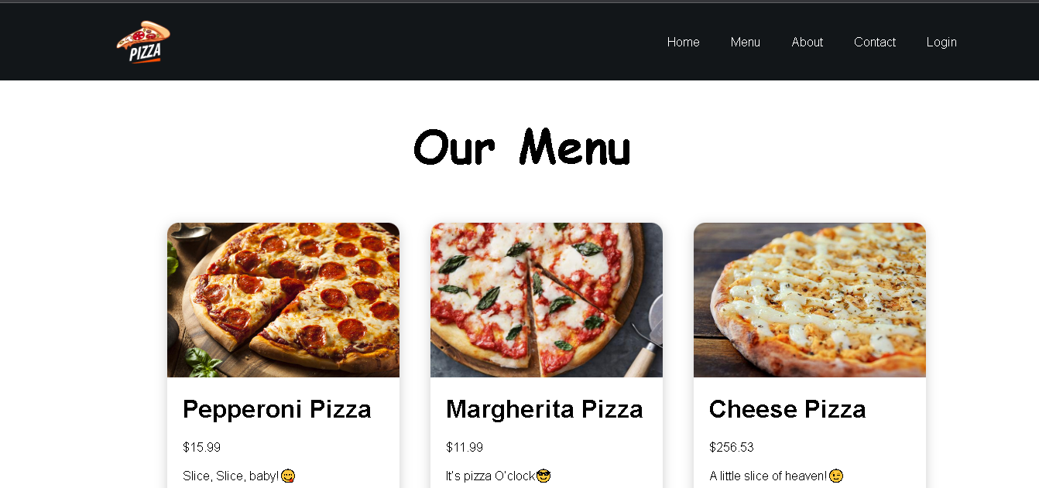

**FIG-7.2 MENU**



**FIG-7.3 CONTACT**

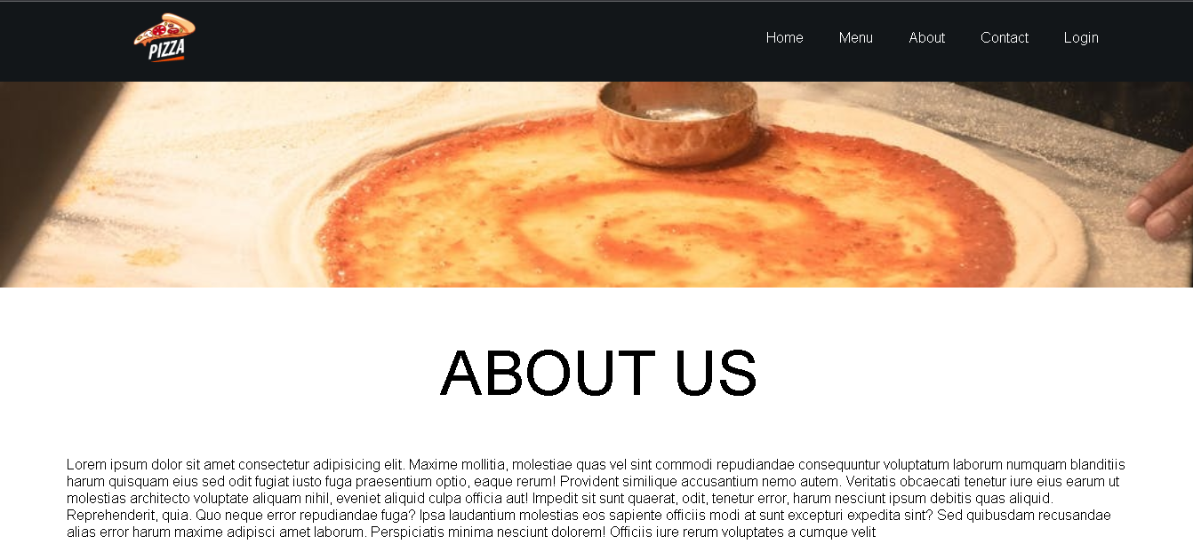

**FIG-7.4 ABOUT US**

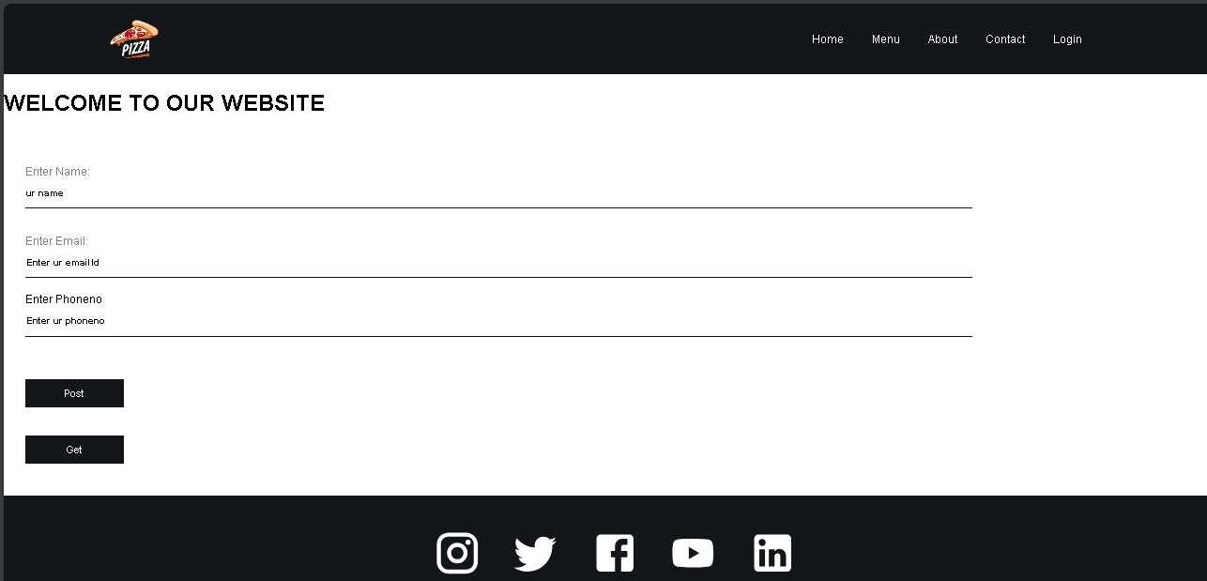

**FIG-7.5 LOGIN**

**Chapter 9: References:**

1. <https://legacy.reactjs.org/docs/getting-started.html>.
2. <https://chat.openai.com/c/32b4912b-a371-4880-b0dc-2e2286415663>
3. <https://react.dev/>
4. <https://developer.mozilla.org/en-US/docs/Learn/Tools_and_testing/Clientside_JavaScript_frameworks/React_getting_started>
5. <https://devdocs.io/react/>
6. <https://www.tutorialspoint.com/reactjs/index.html>
7. <https://www.javatpoint.com/reactjs-tutorial>
8. https://www.w3schools.com/REACT/DEFAULT.ASP
9. <https://www.w3schools.com/mongodb/>
10. https://www.mongodb.com/

**Github link:** [**https://github.com/vyshnavi9241/pizza**](https://github.com/vyshnavi9241/pizza)

**Vecel link:** **https://pizza-ih11.vercel.app/**